**Implementing Machine Learning for Smart Farming**

**Aditya Kumar Mishra, Abhishek Pal and Rohit Agarwal**

BTech Scholar Computer Science & Engineering, B. N. College of Engineering & Technology, Lucknow, India

Assistant Professor, Department of Computer Science & Engineering, B. N. College of Engineering &

Technology, Lucknow, India

adityaadtiya5160@gmail.com

mr.abhipal2002@gmail.com

rarohitagarwal0@gmail.com

**Abstract:**

An essential element of the Indian frugality is husbandry. still, India's husbandry is presently going through a structural metamorphosis that's creating a catastrophe. The only way to resolve the situation is to do all within your power to turn husbandry into a successful business and draw growers back to continue growing crops.

In an attempt in that direction, this exploration composition would use machine literacy to help growers in making informed opinions about their crops. This work focuses on applying supervised machine learning algorithms to estimate agrarian yield grounded on literal data and the suitable crop depending on meteorological conditions. likewise, an online operation has been created.

**INTRODUCTION:**

The core of the Indian frugality is husbandry. still, abecedarian changes in India's husbandry are creating a catastrophe. Agriculture's commensurable share of the GDP has been gradationally dropping over time. The fact that India is getting a net importer of food rather of a country that can sustain itself on its own is concerning. All of these patterns suggest that India's husbandry assiduity is presently passing a extremity. It's suggested that India's agrarian problem has far- reaching counteraccusations that will presumably have an impact on all other sectors of the country's frugality in different ways.

The only way to end the situation is to do all within your power to turn husbandry into a successful business and draw growers back to continue growing crops.

Farmers used to forecast their yield based on yield experiences from the previous year. Therefore, there are various methods or algorithms for this type of data analytics in crop prediction, and we can forecast crop production with the aid of those algorithms. The growing of crops at the proper time and location is not something that modern people are aware of. Even after examining every issue and problem—including weather, temperature, and other factors—no appropriate technology or remedy exists to address the current state of affairs.

Making judgments regarding agricultural risk management requires accurate knowledge about past crop yield trends. Thus, this research suggests a method to forecast crop yield and agricultural conditions based on historical crop data and climatic circumstances. Before cultivating in the field, the farmer will measure the crop's yield per acre.

1. Predicting crop and yield using machine learning techniques is one of the key goals.
2. Conducting a thorough analysis and processing of the data to produce more accurate predictions.
3. To enhance machine learning models' functionality.
4. To create a user-friendly online application. Agriculture, also known as farming, is a fundamental practice involving the cultivation of crops and the raising of livestock, which significantly contributes to a country's economic wellbeing. It serves as a primary source of raw materials and food products essential for various industries and everyday consumption. Raw materials like cotton and jute are pivotal for manufacturing numerous goods used in daily life, showcasing the vital role of agriculture beyond food production. Traditional farming methods, predominantly practiced worldwide, rely on techniques passed down by seasoned farmers, often resulting in labour-intensive processes and time-consuming operations.

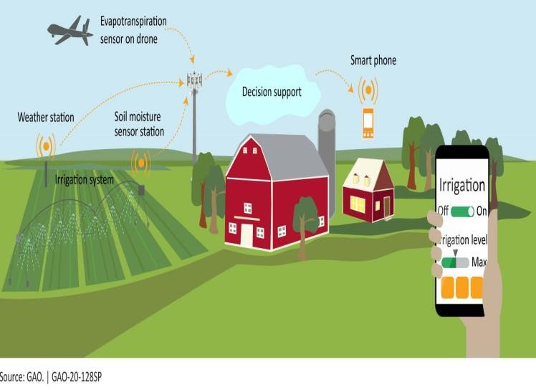

Precision Agriculture, characterized by the application of digital technologies such as robots, electronic devices, sensors, and automation, marks a significant shift in farming practices. This innovative approach aims to streamline workloads, enhance profitability, and facilitate better decision-making processes. Precision Agriculture, also known as precision farming, employs a systematic farming control system that addresses spatial and temporal variations in crops and soil, ultimately maximizing profitability and optimizing yield while improving production quality.

The adoption rate of Precision Agriculture varies based on factors like the type of farming enterprise and geographic location. High-value enterprise farms tend to have higher adoption rates compared to low-value ones. Additionally, adoption rates can vary from one country to another and within different geographical regions. For instance, adoption rates in mountainous zones tend to be lower compared to those in valley regions. This variation is often attributed to the substantial investments required for implementing Precision Agriculture practices.

To encourage broader adoption across all farm sizes, there is a growing need to mitigate the high costs associated with precision agriculture machinery and technologies. By exploring cost-effective solutions, the agricultural sector can promote the widespread adoption of Precision Agriculture practices, thereby fostering sustainable farming practices and improving overall agricultural productivity.

Agriculture encompasses seven crucial steps that are integral to successful crop cultivation and management. These steps include Land Management, Soil Preparation, Water Monitoring, Weed Identification, Pesticide Recommendation, Identifying Diseased Crops, and Cost Estimation.

Land Management involves monitoring physical features such as weather conditions and geological characteristics, which vary significantly across different regions. Understanding these variations is essential as they directly impact crop growth and productivity. Rainfall, for example, is a critical aspect of the earth's climate, and its unpredictability can have profound effects on agriculture, water management systems, and biological systems. Therefore, tools that predict rainfall in advance are invaluable for simplifying crop management processes.

Soil, another vital component of agriculture, influences various factors affecting plant growth, including rooting, moisture retention, nutrient storage, and anchoring. Soil preparation begins with soil testing, which assesses current nutrient levels and determines the appropriate amount of nutrients required based on soil fertility and crop demands. Key parameters such as Phosphorus, Potassium, Nitrogen, Organic Carbon, Boron, and soil pH are analysed from soil test reports to inform soil management practices.

Irrigation, a crucial aspect of agriculture, contributes significantly to water and soil conservation efforts. Complex data related to soil, climate, crop characteristics, and irrigation systems are utilized to optimize irrigation efficiency and consistency. By integrating these factors, farmers can make informed decisions to ensure adequate water supply while minimizing water wastage and soil erosion.

Machine learning, a subset of artificial intelligence, revolutionizes various sectors of the global economy by automating data learning processes without direct human intervention. Its impact is particularly profound in world trade, where it has significantly mitigated communication barriers by facilitating the availability of translation services in over three hundred languages. In the banking and FinTech sectors, machine learning facilitates automatic communication with clients, reducing the risk of abuse and enhancing operational efficiency. Moreover, in agriculture, machine learning plays a pivotal role in crop management, soil management, livestock management, and other related areas.

The study elucidates the fundamental concepts of machine learning and examines diverse machine learning techniques utilized in agriculture. Its primary objective is to enhance understanding of artificial intelligence techniques applicable to agricultural practices. Furthermore, the paper endeavours to elucidate the utilization of IoT (Internet of Things) in agriculture, aiming to establish a sustainable agricultural model that leverages advanced technological capabilities for improved efficiency and productivity.

Through comprehensive exploration and analysis, this research contributes to the advancement of knowledge regarding the application of machine learning in agriculture, offering insights into innovative approaches and strategies for sustainable agricultural development.

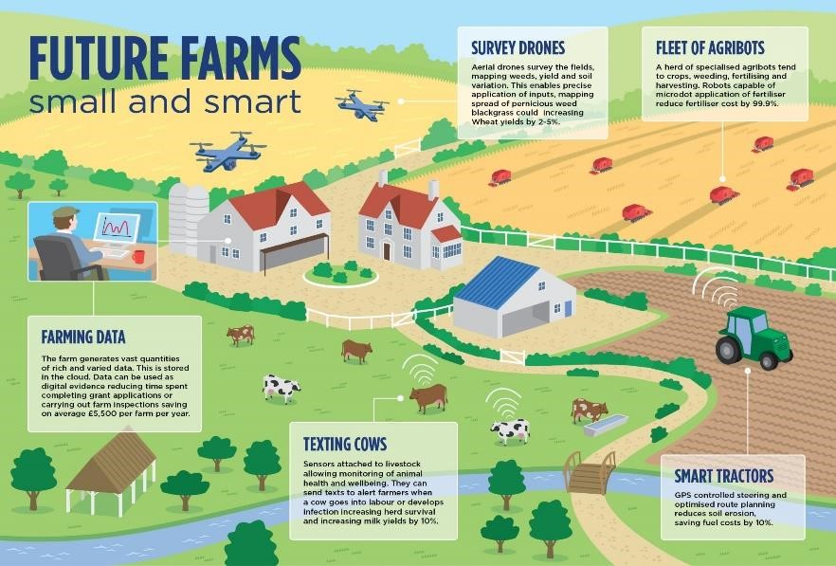

**Fig reference**[: Smart Farming: are robust sensors and the power of the cloud the perfect recipe? - We speak IoT](https://www.wespeakiot.com/robust-sensors-and-the-power-of-the-cloud-the-perfect-recipe-for-smart-farming/)

|  |
| --- |
| risks, and promote sustainable agricultural practices for long- computers in a manner similar to human learning. This data, referred term productivity and environmental conservation. to as training data, enhances accuracy, simplifies tasks, and enriches user experiences. In machine learning, data typically falls into four **PROBLEM STATEMENT:** categories: numerical, categorical, time-series, and text [6].  Predicting crop production and choosing the right crop are crucial |

Overall, these steps underscore the importance of comprehensive planning and management practices in agriculture. By employing advanced technologies and data driven approaches, farmers can enhance crop yields, mitigate agricultural issues. The goal of this project is to use machine learning algorithms to forecast the yield of a crop based on the season and field area, as well as to predict a suitable crop based on the location and climate characteristics provided.

**LITERATURE REVIEW:**

Several studies explore diverse machine learning approaches for predicting crop yield and providing recommendations to farmers. One such study, focused on predicting crop yield using the Random Forest algorithm based on real data from Tamil Nadu, aimed to provide insights into optimizing agricultural output ([18]). [http://www.ijesrt.com/issues%20pdf%20file/Archive-2018/April2018/1.pdf](http://www.ijesrt.com/issues%20pdf%20file/Archive-2018/April-2018/1.pdf)

Another research project, presented at the International Conference on Computer Communication and Informatics (ICCCI), introduced Crop Advisor, a web-based tool utilizing the C4.5 algorithm to forecast the impact of climatic parameters on crop yields in Madhya Pradesh ([19]).

https://ieeexplore.ieee.org/document/6921718

In a different analysis published in the International Journal of Research in Engineering and Technology, efforts were made to develop a user-friendly interface for farmers by employing various data mining techniques to predict rice production ([17]).

https://pdfs.semanticscholar.org/3376/e91c3a77a54

7ce51cfe4a2e68ea6f35ffe63.pdf

Meanwhile, a study from the Institute on the Environment, University of Minnesota, highlighted Random Forests as an effective machine learning method for global and regional crop yield predictions ([20]).

Moreover, a project focused on assisting novice farmers employed the Naive Bayes Gaussian classifier with a boosting algorithm to predict crops accurately ([21]).

The concept of Smart Farming Prediction involved integrating machine learning with environmental factors like soil, weather, and crop type to forecast the most profitable crops to grow ([22]). Lastly, a proposed model cantered on a Naïve Bayes MapReduce Precision Agricultural Model for crop prediction in Indian regions, aiming to provide efficient crop recommendations and insights into optimal sowing and plant growth conditions ([23]).

Each study contributes unique methodologies and insights into leveraging machine learning for crop yield prediction and agricultural decision-making, emphasizing practical applications and benefits for farmers. Through these diverse approaches, researchers aim to enhance agricultural productivity and support informed decision-making in the farming community.

**MACHINE LEARNING:**

In simple terms, machine learning involves using data to teach Various statistical tools are employed to evaluate the performance of machine learning models and predict outcomes effectively. These tools aid in assessing the effectiveness of the algorithms and their ability to achieve desired results.

Machine learning is broadly categorized into supervised and unsupervised learning. In supervised learning, data is manually labelled and used to train the machine learning model, providing examples of inputs and expected outputs. Conversely, unsupervised learning involves the machine interpreting data without explicit guidance or labels, allowing it to discern patterns and relationships independently. These distinctions offer different approaches to training machines and extracting insights from data.

The machine learning algorithm operates on data and generates decision-making outputs based on past experiences [7]. For instance, in agriculture, predictions are made concerning weather conditions; if the temperature falls below 17 degrees Celsius, the soil tends to become moist, indicating unfavourable conditions for cropping or harvesting. The focus of the research is to elucidate explanations pertinent to agriculture while delving into the limitations of such predictions.

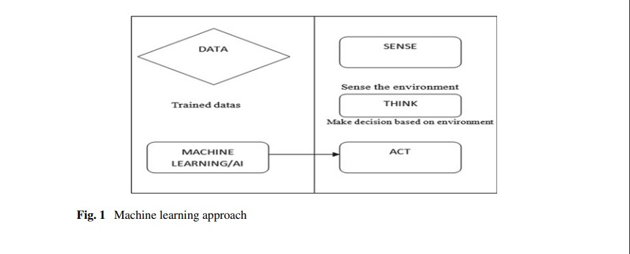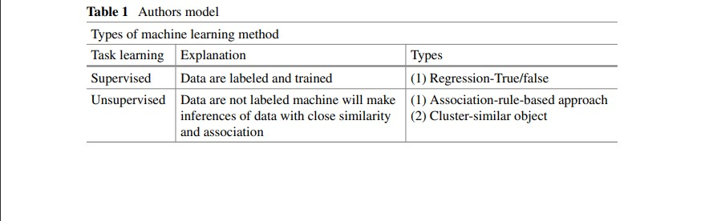

**SUPERVISED LEARNING MODELS REGRESSION:**

Regression is a statistical method utilized to determine the relationship between two variables and is primarily employed to forecast causal effects. It can be categorized into two types: single regression and multiple regression. Single regression involves one feature or variable, while multiple regression involves more than one feature. In single regression, the subcategories include linear regression and non-linear regression. In machine learning, regression techniques encompass linear regression, polynomial regression, support vector regression, decision tree regression, and random forest regression. These methods serve to model and predict relationships between variables in various contexts.

**CLASSIFICATION-BAYESIAN MODELS (BM):**

In Bayesian models (BM), the output result relies on probability; these models are applicable in both classification and regression tasks. Several algorithms fall under the umbrella of Bayesian models, including Naive Bayes, Gaussian Naïve Bayes, the mixture of Gaussian, and Bayesian networks [8] (Pearl, Duda & Hart).

**ARTIFICIAL NEURAL NETWORKS (ANNS):**

Artificial Neural Networks (ANN) are structured akin to the neural networks in the human brain, comprising interconnected processing units. These networks are organized into layers, including input layers, hidden layers, and output layers [3]. A deep artificial neural network, also known as deep learning, encompasses multiple layers for processing data, as depicted.[4] Deep learning represents a novel algorithm within machine learning, wherein data extraction is autonomously conducted. This type of data processing is observed in both supervised and unsupervised learning contexts, as highlighted in research literature [5].

**CROP MANAGEMENT:**

The process of training machines to make decisions is extensively employed for predicting future outcomes. Machine learning simplifies human thought processes by breaking down complex problems, leading to more straightforward decision-making. Agriculture holds a pivotal role in the global economy, particularly concerning global food security and addressing climate change. Forecasting crop yields is a crucial challenge in agriculture, as it depends on various factors such as weather conditions (rainfall, high temperatures, etc.) and the application of pesticides [9]. It is essential to predict and mitigate these factors to ensure stable and sustainable crop production, thereby addressing global food security concerns and reducing the impacts of climate change on agriculture.

**DISEASE DETECTION:**

In traditional agricultural practices, the common approach to treating diseased plants involves spraying chemical pesticides across the entire farmland. However, machine learning (ML) offers a significant advantage by employing trackers equipped with cameras. These trackers enable computers to detect diseased crops and spray chemicals only in the affected areas, thereby minimizing chemical usage. Another method involves detecting parasites in strawberry crops and selectively spraying chemicals in the fields. Screening for banana disease in crops aims to optimize yield by identifying and treating the disease. For wheat crops, which are a prominent global food source, the method involves assessing the health of wheat canopies using genetically enhanced imaging data. Additionally, recent research [1] has focused on disease detection using algorithms integrated with image sensors, particularly employing CNN-based algorithms for accurate detection.

**WEED DETECTION:**

Weeds are unwanted plant growths that compete with crops for nutrients and space, posing a significant challenge in agriculture. The initial investigation into weed detection using machine learning was conducted by Pantazi et al. [10]. They utilized counter-based image sensors captured by drones (UAS) to identify Carduus marinas weeds, which were subsequently removed. In another study by Pantazi et al. [11], weeds and main crops were accurately categorized to enhance weed detection precision. Lastly, a research review [12] explored weed detection using Support Vector Machines (SVM) in plain crop fields.

**WATER MANAGEMENT:**

Water management is crucial in agriculture, but traditional methods struggle with accurately predicting climatic changes and maintaining agronomical balance. The paper delves into the concept of evapotranspiration, which refers to the period between water absorption by the land and its evaporation from plant surfaces into the atmosphere. It focuses on daily and monthly forecasts of evapotranspiration to aid farmers in water management and field planning. Mehdizadeh et al. [13] conducted research revealing that dried and semi-dried lands experience faster evaporation, leading to climatic changes. To gather data on these changes, they established weather forecast stations and collected relevant data.

**SOIL MANAGEMENT:**

The soil serves as a vital resource for sustaining life on Earth, with its layers supporting planting and soil fertility through microbial activity. Predicting climate change relies significantly on soil temperature, which plays a pivotal role in such forecasts. One study [14] aimed to identify soil dryness using data and evapotranspiration to furnish insights for remote decision-making. Another investigation by Morellos et al. [15] introduced a self-evolution method termed SAE_ELM, which assesses soil at six different depths ranging from 5 to 100 cm, emphasizing accuracy in soil management. In agricultural AI, various models have been developed to manage farms, including those focused on crops, water, and soil management. Tables 2, 3, and 4 elucidate different AI models used in agriculture, showcasing their diverse applications and contributions to effective farm management.

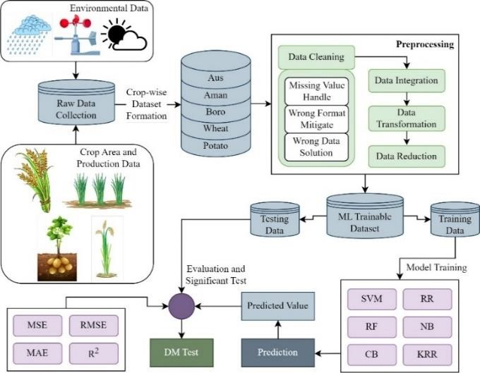

**Fig:** Machine Learning Algorithm Models

**Fig Reference:** [https://www.frontiersin.org/articles/10.3389/fpls.2023.1234555/ful l](https://www.frontiersin.org/articles/10.3389/fpls.2023.1234555/full)

**DISCUSSION:**

The study encompasses a total of 40 articles, focusing on crop management, water management, and soil management methods popular between 2015 and 2021. While the discussion covers various methods, it provides a concise overview in tabulated format, acknowledging that it may not encompass the entirety of each paper. The review research is deemed valuable in terms of its threat and validity assessment [16].

The search strategy was refined to align with the research scope, employing manual searches using keywords like "machine learning" and "yield prediction" across Google Scholar, Scopus, and Web of Sciences. Exclusions were made for publications in other languages, articles not available open-source, and those published before 2014, which were used to extract common algorithm terms for machine learning. The study introduces a novel sustainable agriculture model leveraging IoT (Internet of Things), filling a gap in past literature by reviewing machine learning models up to 2021.

**METHODOLOGY:**

Smart Husbandry exercising machine literacy involves the integration of advanced technologies to optimize agrarian practices. The methodology for enforcing smart husbandry begins with the collection of applicable agrarian data, including environmental factors similar as soil humidity, temperature, and rainfall conditions. This data accession process may involve colourful detectors stationed across the cropland to gather real- time information. Once the data is collected, it undergoes preprocessing to clean and prepare it for analysis. This step ensures that the data is accurate and dependable for posterior machine learning algorithms.

Next, machine literacy algorithms are applied to the pre-processed data to prize meaningful perceptivity and patterns. These algorithms can encompass a range of ways, including supervised literacy, unsupervised literacy, and underpinning literacy, depending on the specific objects of the smart husbandry system. Supervised literacy algorithms, for case, can be used to prognosticate crop yields grounded on literal data and environmental factors, while unsupervised literacy algorithms may identify anomalies or patterns in the data that mortal spectators might miss.

**Fig Reference**; [- Overview on Smart Farming – Rethink Events](https://www.rethinkevents.com/2015/09/overview-on-smart-farming/)

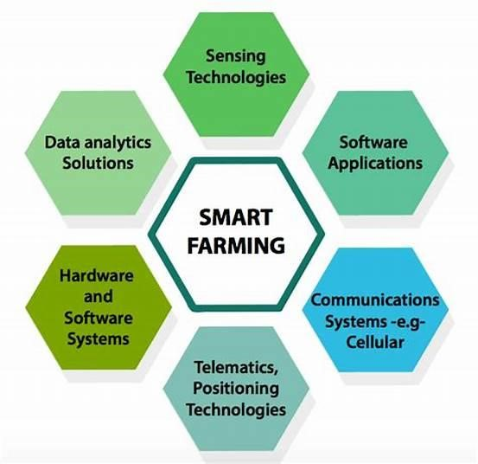

After training the machine learning models, they are deployed in the agricultural environment to provide actionable insights and recommendations to farmers. These insights can inform decisions related to irrigation scheduling, pest and disease management, crop rotation, and resource allocation, ultimately optimizing farm productivity and sustainability. Continuous monitoring and feedback mechanisms are established to ensure that the smart farming system adapts to changing environmental conditions and improves its predictive capabilities over time.

**Crop Recommendation:**

The training model utilized crop recommendation data, which includes various attributes like temperature, humidity, average rainfall, soil pH, nitrogen requirement ratio, potassium requirement ratio, and phosphorous requirement ratio. These attributes are crucial for predicting the suitable crop for cultivation. Following the prediction process, datasets containing soil names and crop names are employed to determine the soil type and scientific name of the predicted crops.

**Data Analytics:**

Before the emergence of information technology, traditional methods such as manual detection of crop diseases and pests, as well as statistical calculations to estimate quantities and predict crop production and losses, were typically laborious, leading to potential human errors stemming from inspectors' limited experience (Rumpf et al., 2010). Machine learning represents the capacity of technology to learn from experiences.

Through data analytics and machine learning, we can extract crucial insights from vast datasets collected from crop fields, unveiling hidden patterns and relationships among various factors influencing horticulture, such as temperature, soil salinity, and humidity. Commonly employed machine learning techniques for forecasting crop diseases and pests utilizing weather data include Artificial Neural Networks (ANNs), SVM Regression, Logistic Regression, neural network-based recognition technology, Support Vector Machines (SVMs) (Singh and Gupta, 2016), and fuzzy technology for recognition.

Singh and Gupta (2018) introduced a system for classifying apple diseases using machine learning classification algorithms. They focused on identifying apple scab and Marconian coronaria by utilizing images of apple tree leaves as input data. Support Vector Machine, K Nearest Neighbour, Decision Tree, and Naïve Bayes algorithms were employed for classification on the same dataset. The simulation of the proposed system was conducted using MATLAB 2016, and their results indicated that K Nearest Neighbour achieved a classification accuracy of 99.4%. The system was developed and tested in the states of Himachal Pradesh and Uttarakhand.

In a study by Shinde and Kulkarni (2017), it was noted that existing agricultural systems lacked reliability and affordability. They proposed integrating IoT and machine learning into precision agriculture for disease prediction in crops. Their system model involved collecting environmental data such as temperature and humidity using sensors, and transmitting the output to local farmers via SMS.

Huang et al. (2018) utilized machine learning techniques to develop intelligent communication systems aimed at enhancing the Quality of Service (QoS) of limited wireless resources. Their approach focused on improving communication efficiency through intelligent machine learning methods.

Overall, the methodology for smart farming using machine learning involves data collection, preprocessing, algorithm selection and training, deployment, and continuous improvement. By leveraging the power of machine learning, smart farming systems can revolutionize traditional agricultural practices, enhance efficiency, and contribute to global food security and sustainability efforts.

**Open Problems Associated with Machine Learning in Agriculture:**

A plethora of reviews in the field of agriculture highlight the diverse applications of machine learning (ML). These reviews have primarily focused on crop disease detection [25,26,27,28], weed detection, yield prediction [29,30], crop recognition water management animal welfare and livestock production. Additionally, some studies have delved into ML methods for major grain crops, examining aspects such as quality and disease detection. There has also been attention given to big data analysis using ML, aiming to address real-life problems arising from smart farming as well as methods for analysing hyperspectral and multispectral data.

Despite the significant progress made in ML applications in agriculture, several unresolved issues persist across various subfields. Commonly referenced problems, as identified in include challenges associated with implementing sensors on farms due to factors like high costs of information and communication technology (ICT), traditional farming practices, and information scarcity. Additionally, many existing datasets lack realism as they are often generated by a limited number of individuals over short periods and from restricted areas [27]. Hence, there is a growing need for more practical datasets sourced directly from fields [30]. Furthermore, there is a demand for more efficient ML algorithms and scalable computational architectures to facilitate rapid information processing [30].

The difficulty of acquiring images, videos, or audio recordings due to lighting changes [28], camera blind spots, environmental noise, and simultaneous vocalization is another significant challenge. Moreover, the majority of farmers lack expertise in ML, making it challenging for them to comprehend the patterns derived from ML algorithms. Therefore, there is a call for the development of more user-friendly systems, including simple visualization tools with intuitive interfaces for data presentation and manipulation. Considering the increasing familiarity of farmers with smartphones, specific smartphone applications have been suggested as a potential solution [27,28].

Lastly, there is a need to foster the development of efficient ML techniques by incorporating expert knowledge from various stakeholders, particularly in computing science, agriculture, and the private sector, to design practical solutions [30]. Current efforts largely focus on individual solutions that may not always align with the decision-making process, unlike in other domains.

Machine learning in agriculture presents numerous challenges and open problems that researchers and practitioners are actively addressing. One significant issue is the need for large and diverse datasets that accurately capture the complexities of agricultural environments. Acquiring such datasets can be challenging due to factors like variability in weather patterns, soil types, and crop diseases across different regions. Additionally, developing machine learning models that are robust to environmental variations and adaptable to changing conditions remains a key challenge. Another concern is the interpretability of machine learning models in agricultural settings, where stakeholders such as farmers and agronomists require insights into model predictions to make

informed decisions

**CONCLUSION:**

The utilization of various algorithm models is widespread in the agricultural sector. The paper provides a concise summary of eight models employed in crop management, including Support Vector Machine (SVM), Expectation Maximization (EM), least square regression, clustering, SOG/MOG, and Support Vector Machine for soil management, models such as IBM/KNN, SVM/LS-SVM, and ANN/SAE are utilized, and for water management, MARS, ANN/GRN, and ANN/ELM are reviewed. Machine learning applications in agriculture predominantly focus on crop management prediction, particularly in crop yield prediction and disease detection. The field of agriculture has witnessed significant advancements through machine learning technologies, facilitating improved crop management practices and disease detection methodologies.

Agriculture serves as the backbone of every nation, necessitating timely monitoring. The modules within the system offer valuable assistance to farmers by aiding in the identification of suitable crops for cultivation based on their geographical location. The identification of weeds and the provision of herbicide recommendations are crucial components. Additionally, all crops are susceptible to insect infestations, making the correct identification of pests and the recommendation of suitable pesticides essential. Many farmers struggle with estimating the costs associated with cultivation, leading to potential losses due to uncertainties. The system also facilitates the estimation of cultivation costs, including expenses related to human and animal labour, seed procurement, as well as the purchase of manures and fertilizers. Moreover, fixed costs are forecasted, offering farmers valuable insights into planning activities and conducting cultivation operations in a profitable manner.

The majority of journal papers have emphasized crop management, while the other three general categories have contributed almost equally. Drawing from the insights of the review paper by [24], the overall landscape appears consistent, with a notable decrease in the percentage of articles concerning livestock from 19% to 12%, favouring those related to crop management.

However, this only presents one facet of the situation. Considering the significant surge in the number of papers published in the last three years, particularly evident with 40 articles identified in [24] compared to the 338 in the current literature survey, there has been approximately a 400% increase in publications on livestock management. Another noteworthy trend is the growing research focus on crop recognition.

Various machine learning (ML) algorithms have been developed to handle the diverse data emanating from agricultural fields, categorized into different families of ML models. Similar to [24], Artificial Neural Networks (ANNs) have proven to be the most efficient ML models. However, contrary to [24], there has been a shift in interest towards Ensemble Learning (EL), which can amalgamate predictions from multiple models.

A new system has been developed to offer crop recommendations tailored to local climate and soil conditions, automate plant watering as needed, and suggest optimal fertilizers based on specific crop types. This technology covers a range of crops including apples, rice, maize, grapes, bananas, oranges, cotton, and coffee, providing farmers with a valuable tool to streamline decision-making processes, minimize manual labour, conserve energy, and enhance output. Looking ahead, there's potential to expand the system by incorporating a disease prediction component, leveraging image classification to anticipate crop diseases.

**REFERENCES:**

1. Ferentinos KP (2018) Deep learning models for plant disease detection and diagnosis. Compute Electron Agric 145:311–318
2. Dipped MA, Wold EH (1985, July) Antialiasing through stochastic sampling. In: Proceedings of the 12th annual conference on computer graphics and interactive techniques (pp 69–78)
3. Hecht-Nielsen R (1987) Counter propagation networks. Appl Opt 26:4979–4983
4. LeCun Y, Bengio Y, Hinton G (2015) Deep learning. Nature 521:436–444
5. Goodfellow I, Bengio Y, Courville A (2016) Deep learning. MIT Press, Cambridge, MA, pp 216–261
6. Grossman SR, Zhang X, Wang L, Engreitz J, Melnikov A, Rogov P, ... and Lander ES (2017) Systematic dissection of genomic features determining transcription factor binding and enhancer function. Proc Nat Acad Sci 114(7):E1291–E1300
7. Dippé MA, Wold EH (1985, July) Antialiasing through stochastic sampling. In: Proceedings of the 12th annual conference on computer graphics and interactive techniques (pp 69–78)
8. . Russell SJ, Norvig P (1995) Artificial intelligence: a modern approach, vol 9. Prentice Hall, Upper Saddle River. ISBN 9780131038059
9. Amatya S, Karkee M, Gongal A, Zhang Q, Whiting MD (2015) Detection of cherry tree branches with fullfoliage in planar architecture for automated sweet-cherry harvesting. Biosyst Eng 146:3–15
10. Pantazi XE, Moshou D, Oberti R, West J, Mouazen AM, Bochtis D (2017) Detection of biotic and abiotic stresses in crops by using hierarchical self-organizing classifiers. Precision Agric 18(3):383–393
11. Pantazi XE, Moshou D, Alexandridis T, Whetton RL, Mouazen AM (2016) Wheat yield prediction using machine learning and advanced sensing techniques. Comput Electron Agric 1(121):57–65
12. Binch A, Fox CW (2017) Controlled comparison of machine vision algorithms for Rumex and Urtica detection ingrassland. Comput Electron Agric 140:123–138
13. Mehdizadeh S, Behmanesh J, Khalili K (2017) Using MARS, SVM, GEP and empirical equations for estimation of monthly mean reference evapotranspiration. Comput Electron Agric 139:103–114
14. Coopersmith EJ, Minsker BS, Wenzel CE, Gilmore BJ (2014) Machine learning assessments of soil drying for agricultural planning. Comput Electron Agric 104:93–104
15. Morellos A, Pantazi X-E, Moshou D, Alexandridis T, Whetton R, Tziotzios G, Wiebensohn J, Bill R, Mouazen AM (2016) Machine learning based prediction of soil total nitrogen, organic carbon and moisture content by using VIS-NIR spectroscopy. Biosyst Eng 152:104–116
16. Šmite D, Wohlin C, Gorschek T, Feldt R (2010) Empirical evidence in global software engineering: a systematic review. Empirical Softw Eng 15(1):91–118
17. D Ramesh, B Vishnu Vardhan. Analysis Of Crop Yield Prediction Using Data Mining Techniques. IJRET:

International Journal of Research in Engineering and Technology

1. P.Priya, U.Muthaiah. Balamurugan.Predicting the yield of the crop using a machine learning algorithm. International Journal of Engineering Science Research Technology.
2. S.Veenadhari, Dr. Bharat Misra, Dr. CD Singh.Machine learning approach for forecasting crop yield based on climatic parameters. International Conference on Computer Communication and Informatics (ICCCI)
3. . Jig Han Jeong, Jonathan P. Resop, Nathaniel D. Mueller,

David H. Fleisher, Kyungdahm Yun, Ethan E. Butler, SooHyung Kim. Random Forests for Global and Regional Crop Yield Predictions. Institute on the Environment, University of Minnesota, St. Paul, MN 55108, United States of America.

1. M. Kalimatthu, M. Kishore P.Vaishnavi Crop Prediction using Machine Learning naive Bayes Gaussian classifier with boosting algorithm.
2. Rashmi Priya, Dharavath Ramesh.2018.” Crop Prediction on the Region Belts of India: A Naïve Bayes MapReduce Precision Agricultural Model”.
3. Igor Oliveira, Renato L. F. Cunha, Bruno Silva, Marco A.

S. Netto.2018.” A Scalable Machine Learning System for

PreSeason Agriculture Yield Forecast.”

1. Abade A., Ferreira P., Vidal F. Plant Diseases recognition on images using Convolutional Neural

Networks: A Systematic Review. *arXiv.* 20202009.04365 [[Google Scholar]](https://scholar.google.com/scholar_lookup?journal=arXiv&title=Plant+Diseases+recognition+on+images+using+Convolutional+Neural+Networks:+A+Systematic+Review&author=A.+Abade&author=P.+Ferreira&author=F.+Vidal&publication_year=2020&)

1. Yashodha G., Shalini D. An integrated approach for predicting and broadcasting tea leaf disease at early stage using IoT with machine learning—A review. *Mater.*

*Today Proc.* 2020

doi: 10.1016/j.matpr.2020.05.458. [[CrossRef]](https://doi.org/10.1016%2Fj.matpr.2020.05.458) [[Google Scholar]](https://scholar.google.com/scholar_lookup?journal=Mater.+Today+Proc.&title=An+integrated+approach+for+predicting+and+broadcasting+tea+leaf+disease+at+early+stage+using+IoT+with+machine+learning%E2%80%94A+review&author=G.+Yashodha&author=D.+Shalini&publication_year=2020&doi=10.1016/j.matpr.2020.05.458&)

1. Yuan Y., Chen L., Wu H., Li L. Advanced agricultural disease image recognition technologies: A review. *Inf.*

*Process. Agric.* 2021

doi: 10.1016/j.inpa.2021.01.003. [[CrossRef]](https://doi.org/10.1016%2Fj.inpa.2021.01.003) [[Google Scholar]](https://scholar.google.com/scholar_lookup?journal=Inf.+Process.+Agric.&title=Advanced+agricultural+disease+image+recognition+technologies:+A+review&author=Y.+Yuan&author=L.+Chen&author=H.+Wu&author=L.+Li&publication_year=2021&doi=10.1016/j.inpa.2021.01.003&)

1. Mayuri K. Role of Image Processing and Machine Learning Techniques in Disease Recognition, Diagnosis and Yield Prediction of Crops: A Review. *Int. J. Adv. Res. Comput. Sci.* 2018;**9**:788–795. [[Google Scholar]](https://scholar.google.com/scholar_lookup?journal=Int.+J.+Adv.+Res.+Comput.+Sci.&title=Role+of+Image+Processing+and+Machine+Learning+Techniques+in+Disease+Recognition,+Diagnosis+and+Yield+Prediction+of+Crops:+A+Review&author=K.+Mayuri&volume=9&publication_year=2018&pages=788-795&)
2. Wang A., Zhang W., Wei X. A review on weed detection using ground-based machine vision and image processing techniques. *Comput. Electron. Agric.* 2019;**158**:226– 240. doi: 10.1016/j.compag.2019.02.005. [[CrossRef]](https://doi.org/10.1016%2Fj.compag.2019.02.005) [[Google Scholar]](https://scholar.google.com/scholar_lookup?journal=Comput.+Electron.+Agric.&title=A+review+on+weed+detection+using+ground-based+machine+vision+and+image+processing+techniques&author=A.+Wang&author=W.+Zhang&author=X.+Wei&volume=158&publication_year=2019&pages=226-240&doi=10.1016/j.compag.2019.02.005&)
3. Su W.-H. Advanced Machine Learning in Point Spectroscopy, RGB- and Hyperspectral-Imaging for Automatic Discriminations of Crops and Weeds: A Review. *Smart Cities.* 2020;**3**:767–792.

doi: 10.3390/smartcities3030039. [[CrossRef]](https://doi.org/10.3390%2Fsmartcities3030039) [[Google Scholar]](https://scholar.google.com/scholar_lookup?journal=Smart+Cities&title=Advanced+Machine+Learning+in+Point+Spectroscopy,+RGB-+and+Hyperspectral-Imaging+for+Automatic+Discriminations+of+Crops+and+Weeds:+A+Review&author=W.-H.+Su&volume=3&publication_year=2020&pages=767-792&doi=10.3390/smartcities3030039&)

1. Chlingaryan A., Sukkarieh S., Whelan B. Machine learning approaches for crop yield prediction and nitrogen status estimation in precision agriculture: A review. *Comput. Electron. Agric.* 2018;**151**:61–69. doi: 10.1016/j.compag.2018.05.012. [[CrossRef]](https://doi.org/10.1016%2Fj.compag.2018.05.012) [[Google](https://scholar.google.com/scholar_lookup?journal=Comput.+Electron.+Agric.&title=Machine+learning+approaches+for+crop+yield+prediction+and+nitrogen+status+estimation+in+precision+agriculture:+A+review&author=A.+Chlingaryan&author=S.+Sukkarieh&author=B.+Whelan&volume=151&publication_year=2018&pages=61-69&doi=10.1016/j.compag.2018.05.012&)

[}Scholar](https://scholar.google.com/scholar_lookup?journal=Comput.+Electron.+Agric.&title=Machine+learning+approaches+for+crop+yield+prediction+and+nitrogen+status+estimation+in+precision+agriculture:+A+review&author=A.+Chlingaryan&author=S.+Sukkarieh&author=B.+Whelan&volume=151&publication_year=2018&pages=61-69&doi=10.1016/j.compag.2018.05.012&)

 

MR. ADITYA KUMAR MISHRA MR. ABHISHEK PAL

BRANCH : CSE(AKTU) BRANCH : CSE(AKTU)